**Report on World Drugs Day Awareness Programme**

**Date:** 26th June 2024  
**Venue:** Seminar Hall, GDC Gummalakshmipuram  
**Organized by:** Department of Chemistry  
**Guest of the Event:** Sub-Inspector, GL Puram Police Station  
**Theme:***"People First: Stop Stigma and Discrimination, Strengthen Prevention"*

On the occasion of the **International Day Against Drug Abuse and Illicit Trafficking**, the **Department of Chemistry** of **Government Degree College, Gummalakshmipuram**, organized an **awareness programme** on **26th June 2024**. The event took place in the **Seminar Hall** of the college and was conducted in alignment with the United Nations' global theme:  
**"People First: Stop Stigma and Discrimination, Strengthen Prevention."**

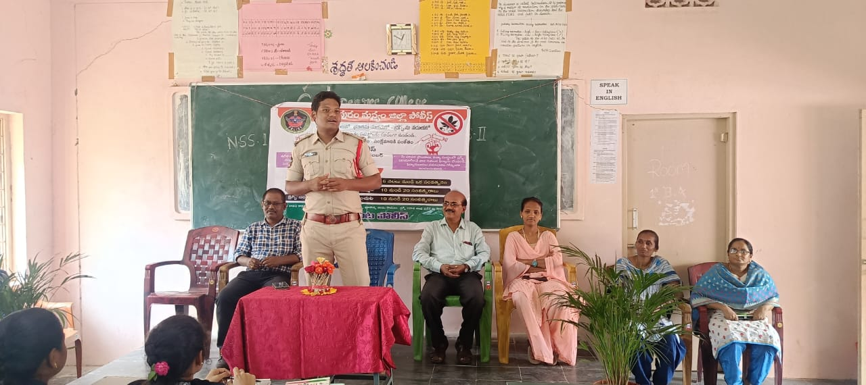

The programme was organized to raise awareness among students about the **dangers of drug abuse**, its impact on physical and mental health, and the importance of eliminating stigma to strengthen prevention efforts.

The event commenced with a powerful address by the **Sub-Inspector of GL Puram Police Station**, who served as the **chief guest**. He delivered an impactful talk emphasizing the legal, social, and health-related consequences of drug abuse, urging students to stay informed and alert.

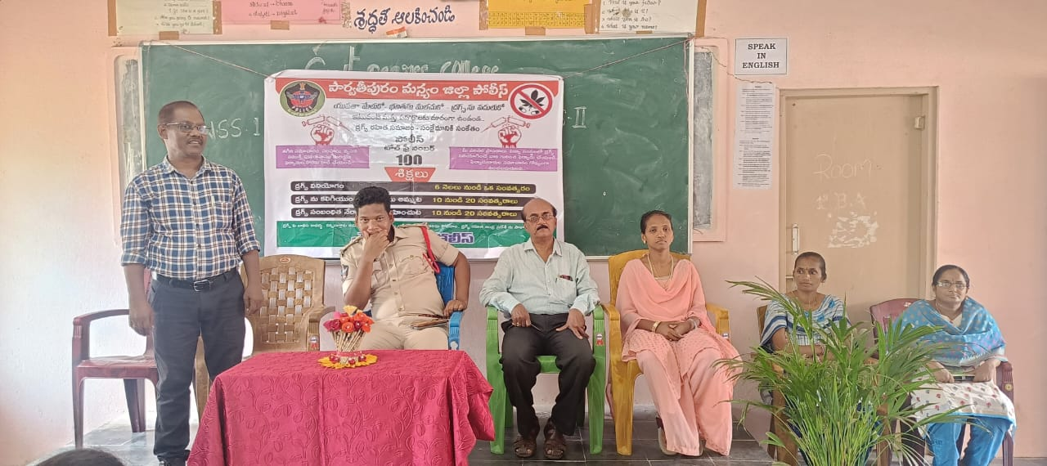

**Sri D. Ramayya**, Vice-Principal of the college, also addressed the gathering and encouraged students to be responsible citizens by helping build a **drug-free society**. He highlighted the significance of such awareness programmes in shaping youth attitudes and preventing substance misuse.

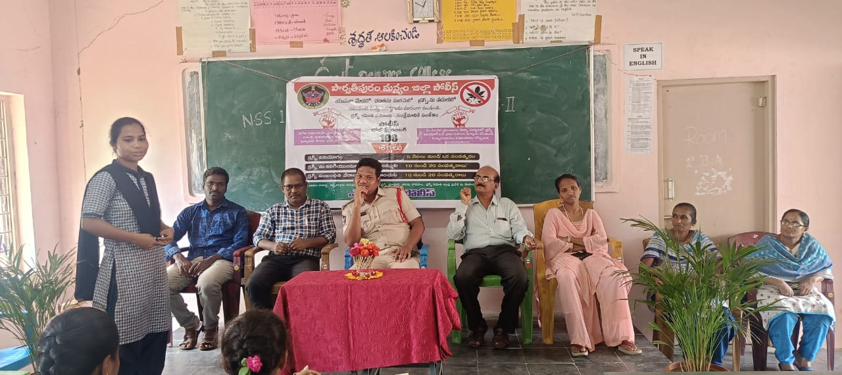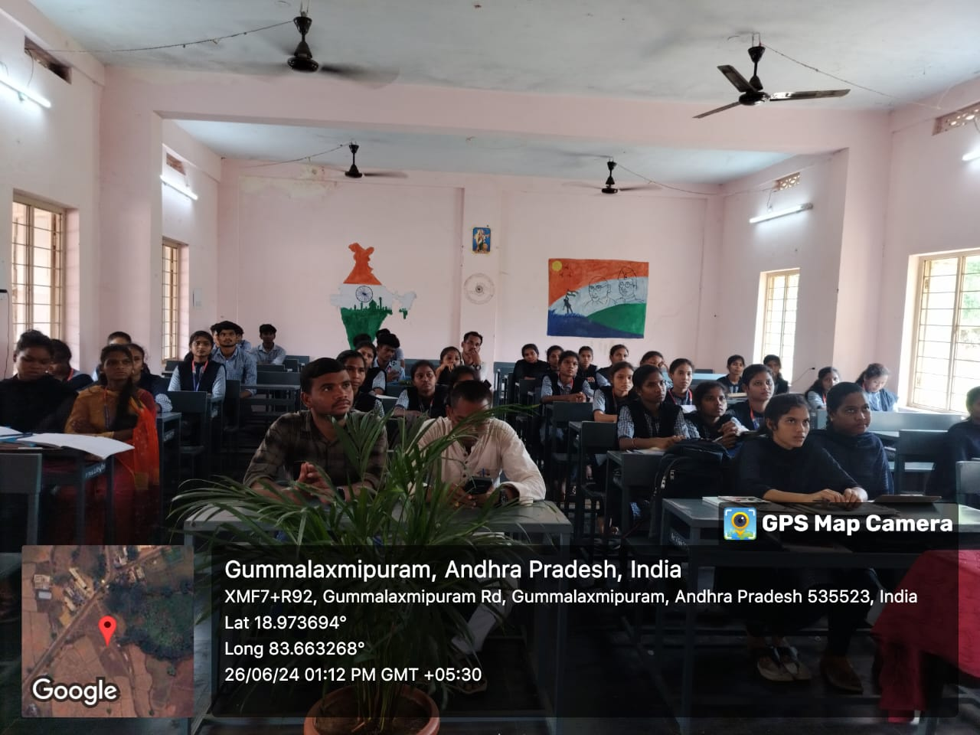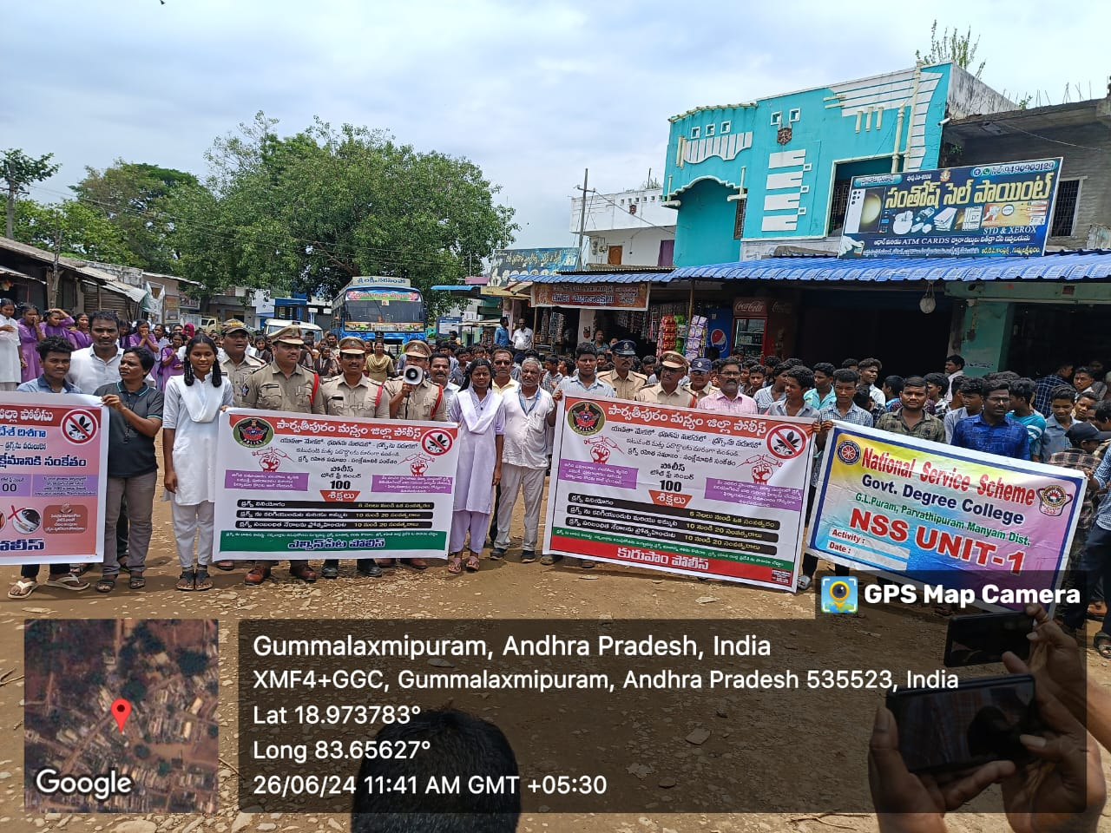

After the formal session, a **rally** was conducted in **Gummalakshmipuram**, led by the **Sub-Inspector** and joined by faculty and students. Participants marched through key areas of the town carrying banners and raising slogans against drug use. The rally served as a **public outreach effort**, drawing attention to the collective responsibility of the community in fighting drug abuse.

The event witnessed active participation from both students and staff and concluded on a highly positive and motivational note. It was a **successful initiative** in spreading awareness and promoting a **healthy and drug-free lifestyle** among youth and the larger community.